**EX:5b**

**DATE : 20.8.2024**

**Design a simple topology using CiscoPacket Tracer**

**AIM :** Analyze the behavior of network devices using CISCO PACKET TRACER simulator.

1. From the network component box, click and drag-and-drop the below components:
   * 1. 4 Generic PCs and One HUB
     2. 4 Generic PCs and One switch

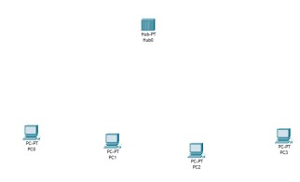

1. Click on Connections:
   1. Click on Copper Straight-Through cable,
   2. Select one of the PC and connect it to HUB using the cable. The link LED should glow in green, indicating that the link is up. Similarly connect remaining 3 PCs to the HUB.
   3. Similarly connect 4 PCs to the switch using copper straight-through cable.

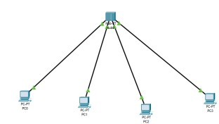

1. Click on the PCs connected to hub, go to the Desktop tab, click on IP Configuration, and enter an IP address and subnet mask. Here, the default gateway and DNS server information is not needed as there are only two end devices in the network.

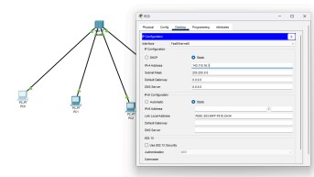

1. Click on the PDU (message icon) from the common tool bar,
   1. Drag and drop it on one of PC (source machine) and then drop it on another PC (destination machine) connected to the HUB.
2. Observe the flow of PDU from source PC to destination PC by selecting the Realtime mode of simulation.

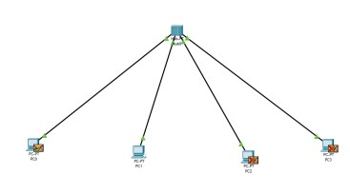

1. Repeat step #3 to step #5 for the PCs connected to the switch.

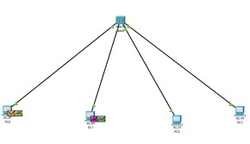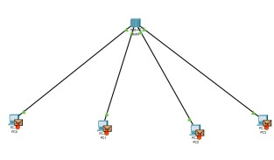

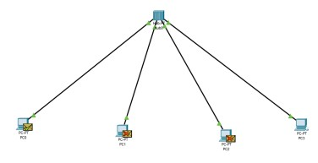

1. Observe how HUB and switch are forwarding the PDU and write your observation and conclusion about the behaviors of Switch and HUB.

**SWITCH:**

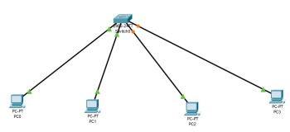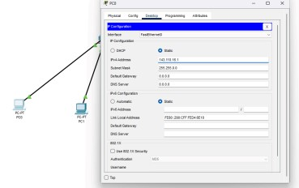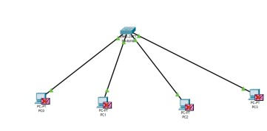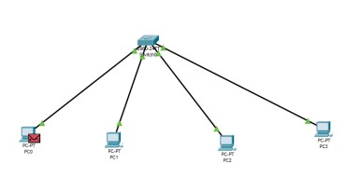

**Student observation:**

1. **From your observation write down the behavior of Switch and HUB in terms of forwarding the packets received by them.**

On Cisco devices, switches and hubs handle packet forwarding differently. A Cisco switch learns the source MAC addresses of incoming frames and updates its MAC address table accordingly. It forwards frames only to the port associated with the destination MAC address, which reduces unnecessary traffic. If the destination MAC address is unknown, the switch broadcasts the frame to all ports except the one it was received on. In contrast, a hub lacks the capability to learn or store MAC addresses; it simply broadcasts all incoming frames to every connected port. This behavior means that all devices on a hub receive the same frames, leading to higher collision rates as all devices share a single collision domain. Thus, switches provide more efficient and targeted forwarding compared to the broadcast-only approach of hubs**.**

1. **Find out the network topology implemented in your college and draw and label that topology in your observation book.**

Hybrid topology

**RESULT :** The behavior of network devices using CISCO PACKET TRACER simulator is analyzed.